Lab 4

Exercise#1: Design full adder using in-built block of (i) 4:1 multiplexer with initial carry as input line and, (ii) 8:1 multiplexer.
Boolean Expressions | Logic Diagram
Full adder using 4 : 1 Mux | 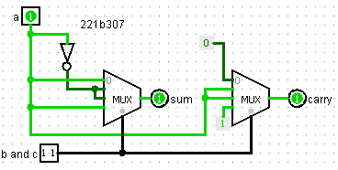
Truth Table or Karnaugh (K) Map

Boolean Expressions | Logic Diagram
Full adder using 8 : 1 Mux | 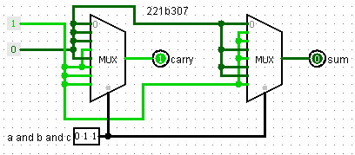
Truth Table or Karnaugh (K) Map

Exercise#2: Design a logic circuit (using in-built block of priority encoder to identify whether the input octal number is even, odd or prime. Use one hex display to show input octal digit and a seven segment display at output which display ‘E’, ‘O’ and ‘P’ if input octal number is even, odd and prime respectively.
Boolean Expressions | Logic Diagram
Even = ~c  odd = c  prime = ~ab+ac | 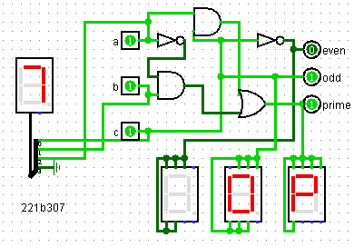
Truth Table or Karnaugh (K) Map
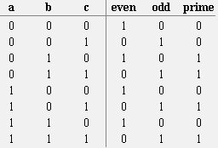

Exercise 3 : Design calendar logic circuit to show the number of days in a given month. Display input
month and leap year using two hex displays and number of days in outputs using two seven segmentdisplays (two displays for each output).

Boolean Expressions | Logic Diagram
X = ~LeapYearBit ~m0 m1 ~m2 y = LeapYearBit ~m0 m1 ~m2 ~m3  z = ~m0 m2 ~m3 + m0 ~m2 m3  u = ~m0 ~m1 m3 + ~m0 ~m2 m3 + m0 ~m3 | 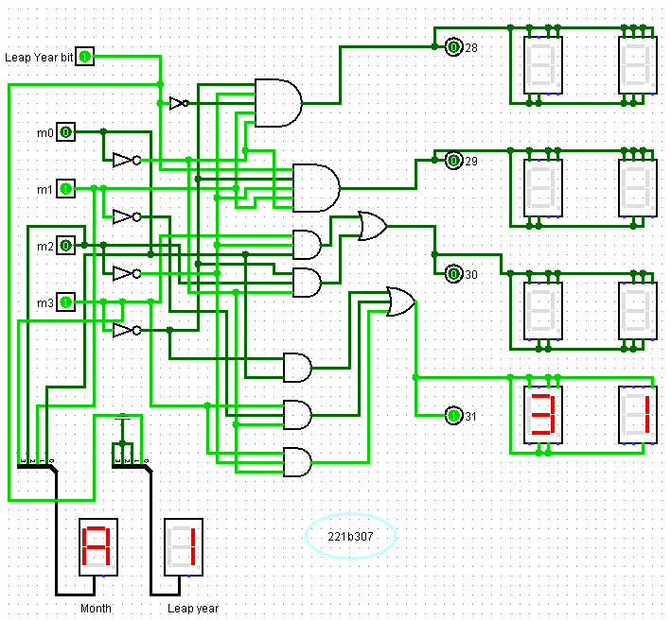
Truth Table or Karnaugh (K) Map

Exercise#4: Design logic circuit to determine whether the input year is leap year or not.
Use four hex displays to show four decimal digits of input year and one hex display to show output
Boolean Expressions | Logic Diagram
 | 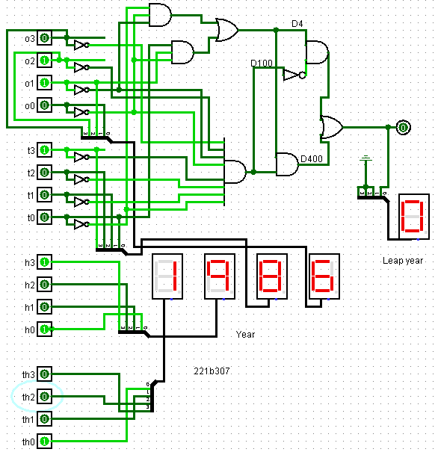
Truth Table or Karnaugh (K) Map

